Name:B.Srujan H.No:2303A51805 Batch:26
SCHOOL OF COMPUTER SCIENCE AND ARTIFICIAL INTELLIGENCE |  |  |  |  | DEPARTMENT OF COMPUTER SCIENCE ENGINEERING
Program Name:B. Tech |  |  |  | Assignment Type: Lab |  |  | Academic Year:2025-2026
Course Coordinator Name |  |  |  | Dr. Rishabh Mittal
Instructor(s)Name |  |  |  | Mr. S Naresh Kumar  Ms. B. Swathi  Dr. Sasanko Shekhar Gantayat  Mr. Md Sallauddin  Dr. Mathivanan  Mr. Y Srikanth  Ms. N Shilpa  Dr. Rishabh Mittal (Coordinator)  Dr. R. Prashant Kumar  Mr. Ankushavali MD  Mr. B Viswanath  Ms. Sujitha Reddy  Ms. A. Anitha  Ms. M.Madhuri  Ms. Katherashala Swetha  Ms. Velpula sumalatha  Mr. Bingi Raju  Mr. G. Kranthi
Course Code |  |  | 23CS002PC304 | Course Title |  | AI Assisted Coding
Year/Sem |  |  | III/I | Regulation |  | R23
Date and Day  of Assignment |  |  | Week 5 - Thursday | Time(s) |  | 23CSBTB01 To 23CSBTB52
Duration |  |  | 2 Hours | Applicable to  Batches |  | All Batches
AssignmentNumber:10.4 (Present assignment number)/24(Total number of assignments)
 | Q.No. | Question |  |  |  |  |  | ExpectedTime  to complete
 | 1 | Lab 9 – Code Review and Quality: Using AI to Improve Code Quality and Readability  Lab Objectives  - Use AI for automated code review and quality enhancement.  - Identify and fix syntax, logical, performance, and security issues in Python code.  - Improve readability and maintainability through structured refactoring and comments.  - Apply prompt engineering for targeted improvements.  - Evaluate AI-generated suggestions against PEP 8 standards and software engineering best practices |  |  |  |  |  | Week 5

Task 1: AI-Assisted Syntax and Code Quality Review

Scenario
You join a development team and are asked to review a junior developer’s Python script that fails to run correctly due to basic coding mistakes. Before deployment, the code must be corrected and standardized.

Task Description
You are given a Python script containing:
- Syntax errors
- Indentation issues
- Incorrect variable names
- Faulty function calls

Use an AI tool (GitHub Copilot / Cursor AI) to:
- Identify all syntactic and structural errors
- Correct them systematically
- Generate an explanation of each fix made

Expected Outcome
- Fully corrected and executable Python code
- AI-generated explanation describing:
  - Syntax fixes
  - Naming corrections
  - Structural improvements
- Clean, readable version of the script
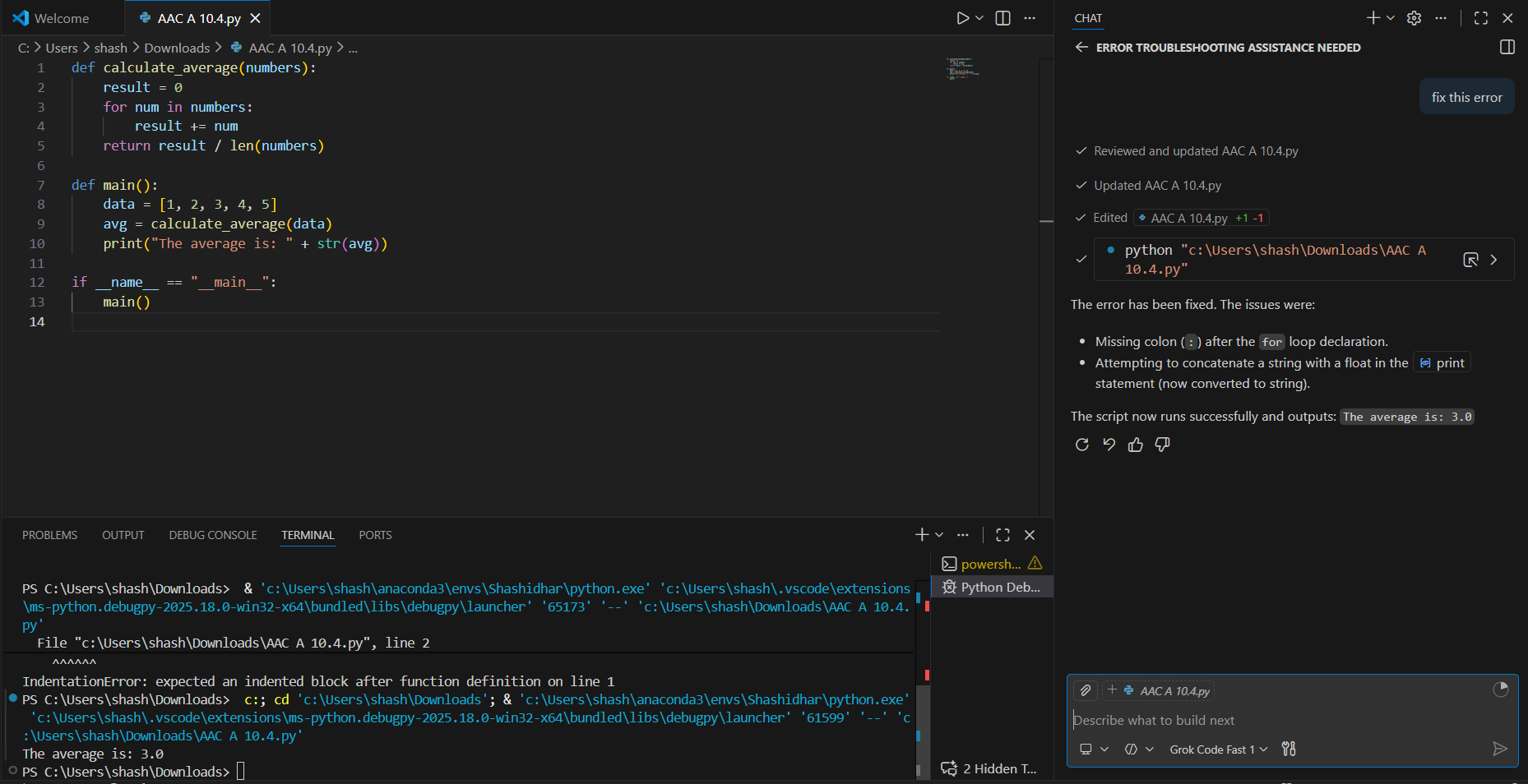

Task 2: Performance-Oriented Code Review

Scenario
A data processing function works correctly but is inefficient and slows down the system when large datasets are used.

Task Description
You are provided with a function that identifies duplicate values in a list using inefficient nested loops.
Using AI-assisted code review:
- Analyze the logic for performance bottlenecks
- Refactor the code for better time complexity
- Preserve the correctness of the output

Ask the AI to explain:
- Why the original approach was inefficient
- How the optimized version improves performance

Expected Outcome
- Optimized duplicate-detection logic (e.g., using sets or hash-based structures)
- Improved time complexity
- AI explanation of performance improvement
- Clean, readable implementation
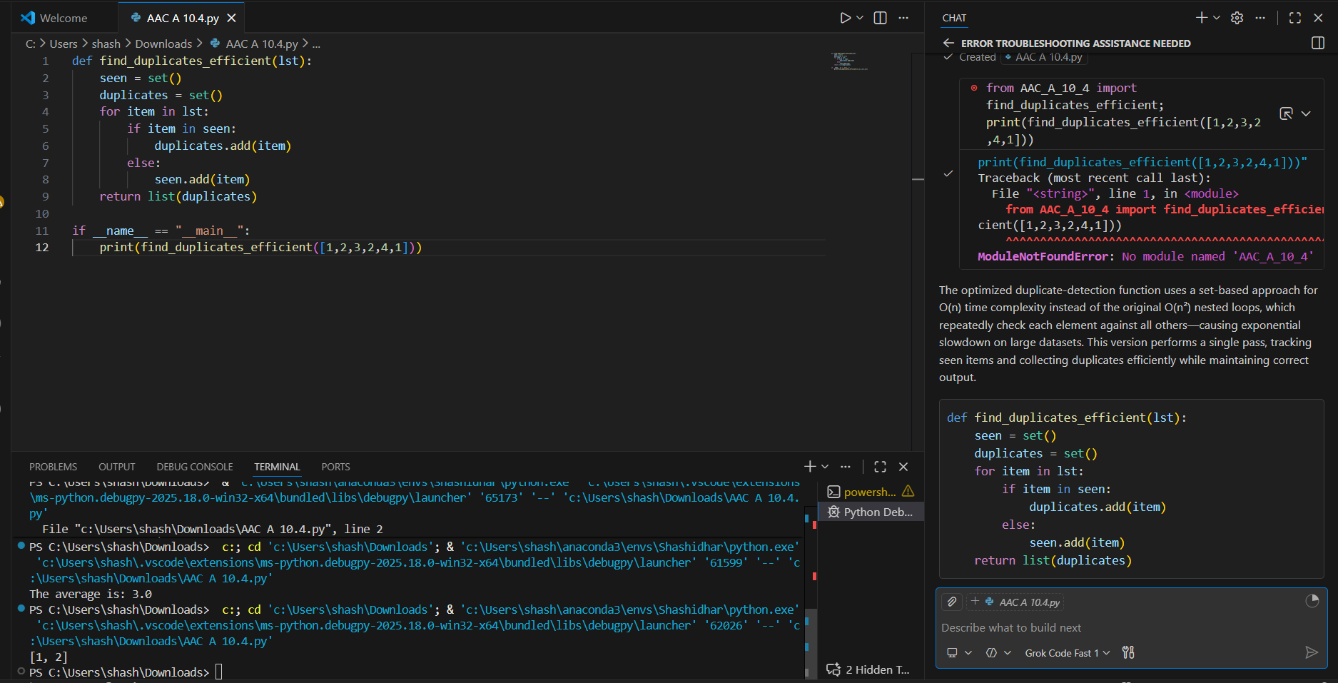

Task 3: Readability and Maintainability Refactoring

Scenario
A working script exists in a project, but it is difficult to understand due to poor naming, formatting, and structure. The team wants it rewritten for long-term maintainability.

Task Description
You are given a poorly structured Python function with:
- Cryptic function names
- Poor indentation
- Unclear variable naming
- No documentation

Use AI-assisted review to:
- Refactor the code for clarity
- Apply PEP 8 formatting standards
- Improve naming conventions
- Add meaningful documentation

Expected Outcome
- Clean, well-structured code
- Descriptive function and variable names
- Proper indentation and formatting
- Docstrings explaining the function purpose
- AI explanation of readability improvements
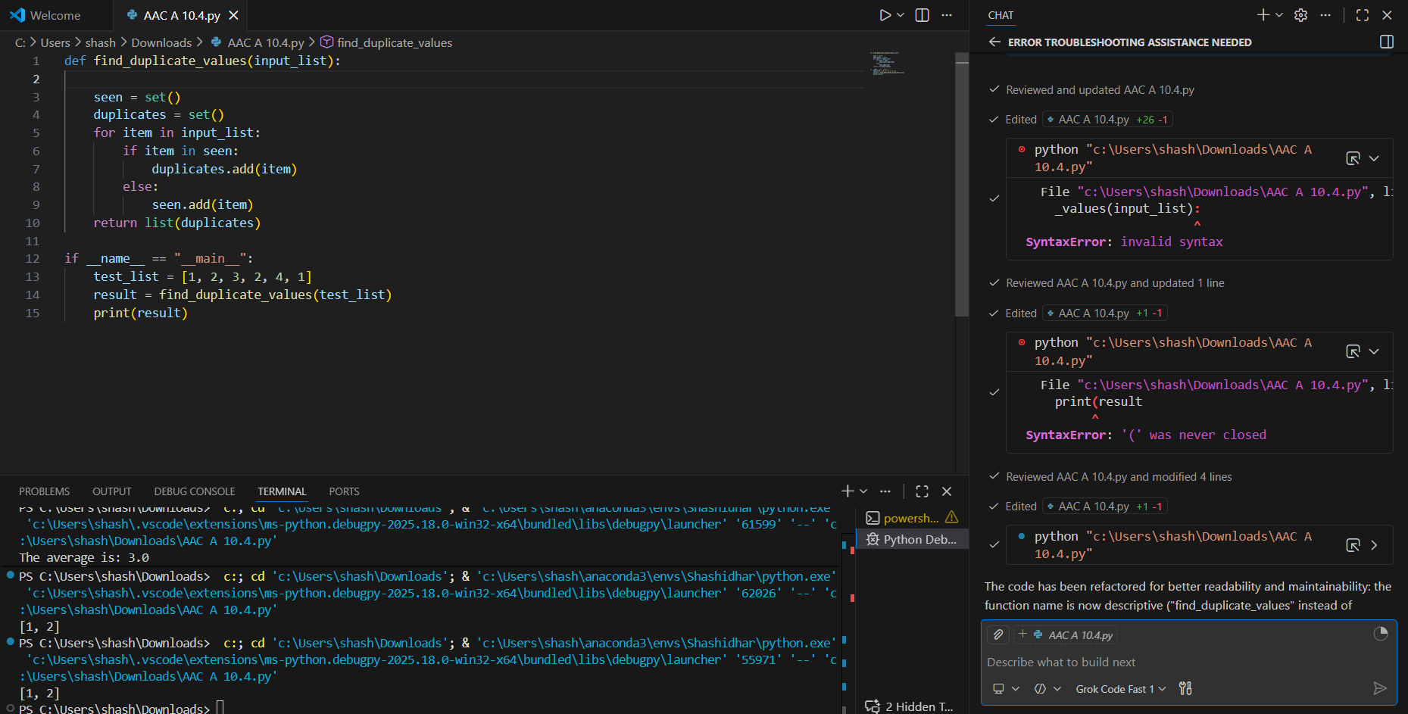
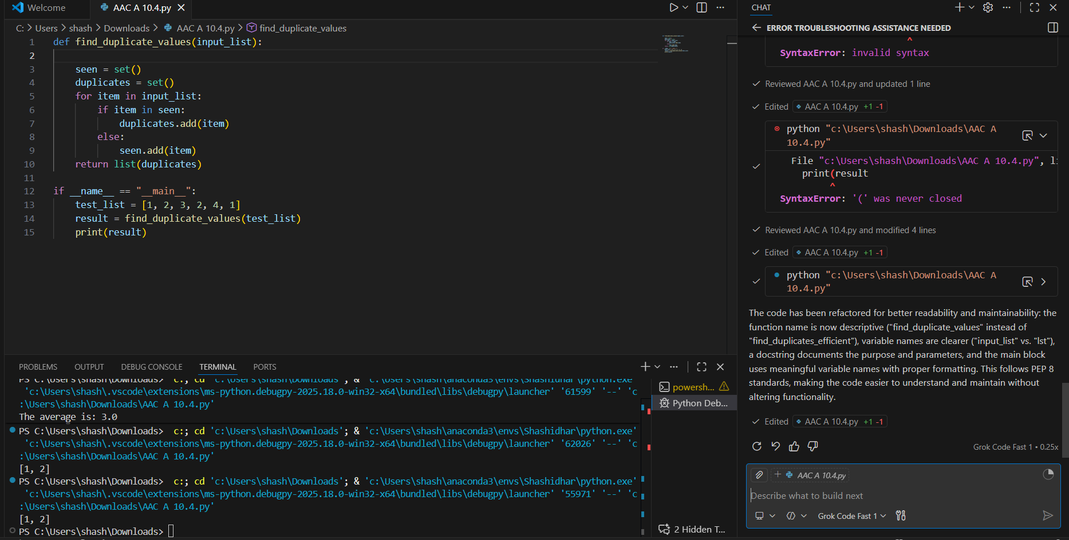

Task 4: Secure Coding and Reliability Review

Scenario
A backend function retrieves user data from a database but has security vulnerabilities and poor error handling, making it unsafe for production deployment.

Task Description
You are given a Python script that:
- Uses unsafe SQL query construction
- Has no input validation
- Lacks exception handling

Use AI tools to:
- Identify security vulnerabilities
- Refactor the code using safe coding practices
- Add proper exception handling
- Improve robustness and reliability

Expected Outcome
- Secure SQL queries using parameterized statements
- Input validation logic
- Try-except blocks for runtime safety
- AI-generated explanation of security improvements
- Production-ready code structure
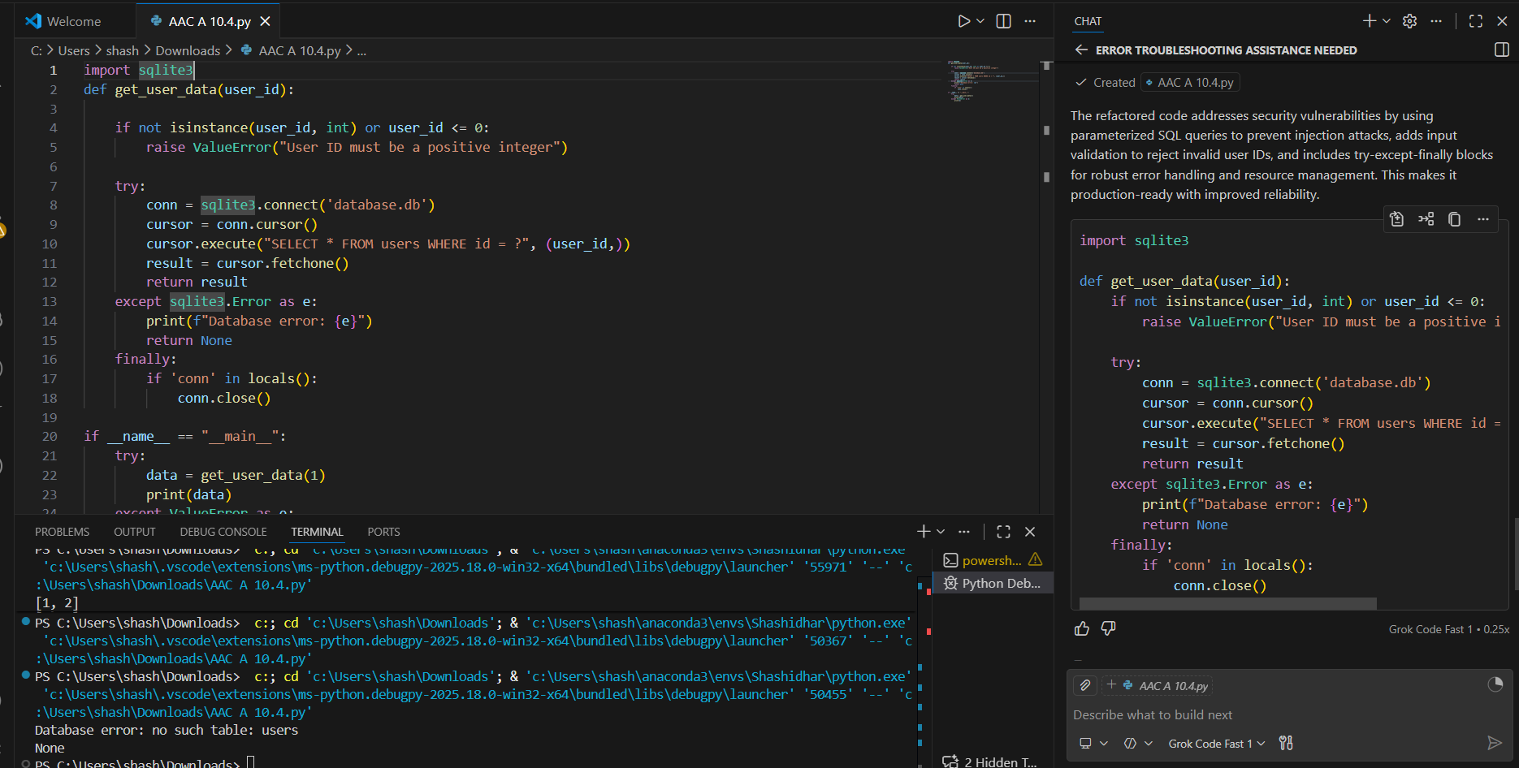

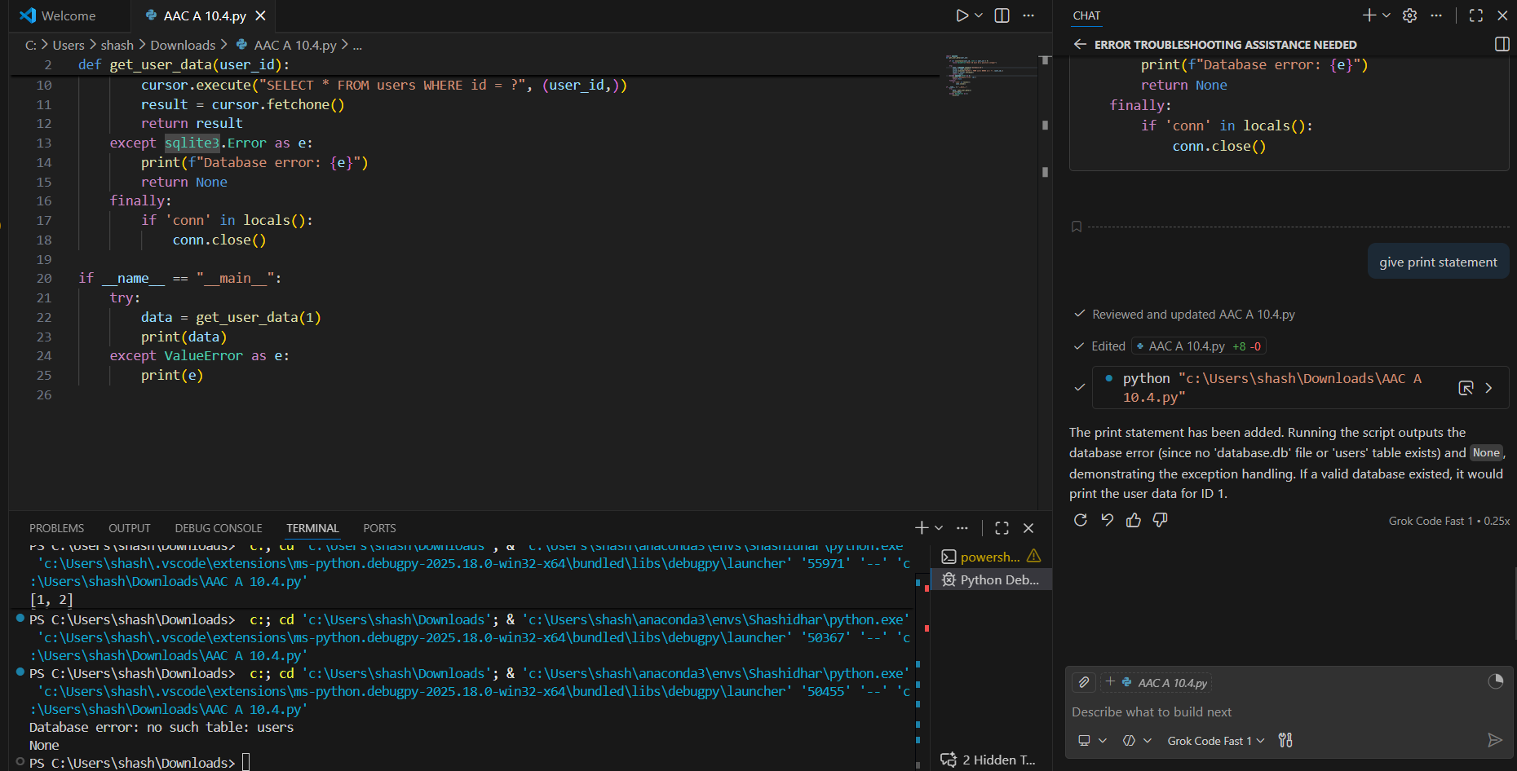

Task 5: AI-Based Automated Code Review Report

Scenario
Your team uses AI tools to perform automated preliminary code reviews before human review, to improve code quality and consistency across projects.

Task Description
You are provided with a poorly written Python script.
Using AI-assisted review:
- Generate a structured code review report that evaluates:
  - Code readability
  - Naming conventions
  - Formatting and style consistency
  - Error handling
  - Documentation quality
  - Maintainability
The task is not just to fix the code, but to analyze and report on quality issues.

Expected Outcome
- AI-generated review report including:
  - Identified quality issues
  - Risk areas
  - Code smell detection
  - Improvement suggestions
- Optional improved version of the code
- Demonstration of AI as a code reviewer, not just a code generator
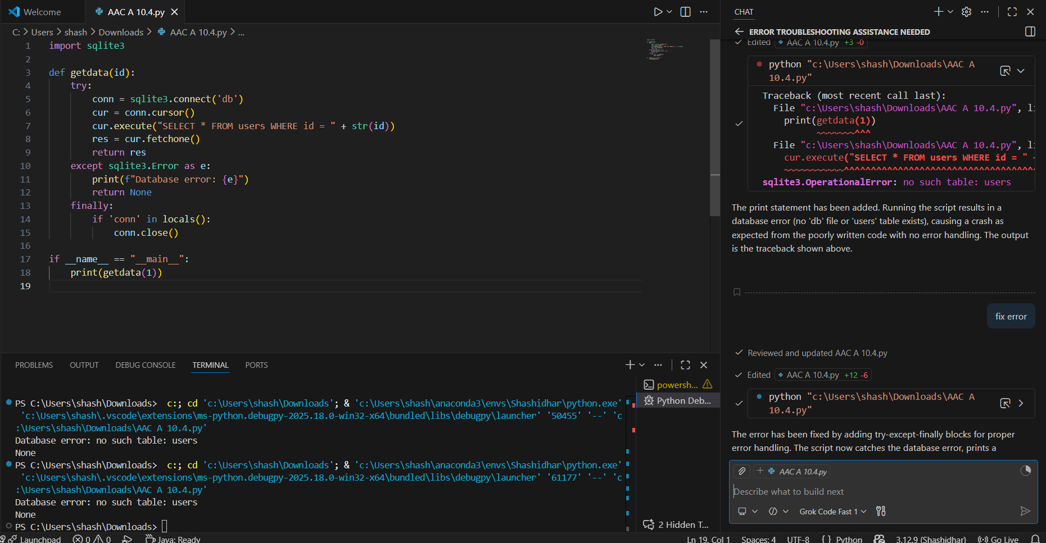

Note: Report should be submitted a word document for all tasks in a single document with prompts, comments & code explanation, and output and if required, screenshots

